EXP 8
Model and verify Modulo-N-Counter (MOD_N)
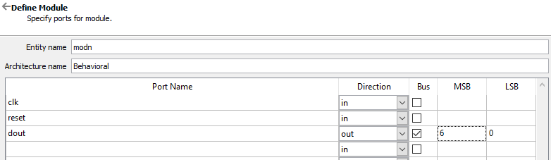
library IEEE;
use IEEE.STD_LOGIC_1164.ALL;
use IEEE.NUMERIC_STD.ALL;

entity modN_counter is
generic(n: integer := 128);
port(
clk : in STD_LOGIC;
reset : in STD_LOGIC;
dout : out STD_LOGIC_VECTOR(6 downto 0)
);
end modN_counter;

architecture A_modN of modN_counter is
begin

counter : process(clk, reset)
variable m : integer range 0 to n-1 := 0;

begin
if (reset = '1') then
m := 0;

elsif rising_edge(clk) then
if (m = n-1) then
m := 0;
else
m := m + 1;
end if;
end if;

dout <= std_logic_vector(to_unsigned(m,7));

end process;

end A_modN;
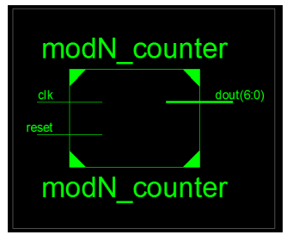
Test bench code
LIBRARY ieee;
USE ieee.std_logic_1164.ALL;
USE ieee.numeric_std.ALL;

ENTITY MOD_TB IS
END MOD_TB;

ARCHITECTURE behavior OF MOD_TB IS

-- Component Declaration
COMPONENT modN_counter
PORT(
clk : IN std_logic;
reset : IN std_logic;
dout : OUT std_logic_vector(6 downto 0)
);
END COMPONENT;

-- Inputs
signal clk : std_logic := '0';
signal reset : std_logic := '0';

-- Outputs
signal dout : std_logic_vector(6 downto 0);

-- Clock period
constant clk_period : time := 10 ns;

BEGIN

-- UUT
uut: modN_counter PORT MAP (
clk => clk,
reset => reset,
dout => dout
);

-- Clock process
clk_process : process
begin
clk <= '0';
wait for clk_period/2;
clk <= '1';
wait for clk_period/2;
end process;

-- Stimulus process
stim_proc: process
begin

-- Reset
reset <= '1';
wait for 20 ns;
reset <= '0';

-- Let counter run
wait for 200 ns;

wait;
end process;

END;

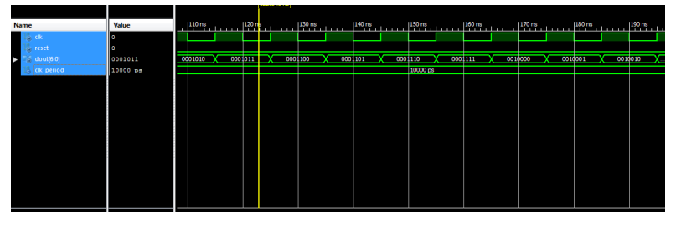
Impleentation Code:
library IEEE;
use IEEE.STD_LOGIC_1164.ALL;
use IEEE.NUMERIC_STD.ALL;

entity modN_counter is
generic(n: integer := 128);
port(
clk : in STD_LOGIC;
reset : in STD_LOGIC;
dout : out STD_LOGIC_VECTOR(6 downto 0)
);
end modN_counter;

architecture A_modN of modN_counter is

signal temp : std_logic_vector(22 downto 0);
signal sclk : std_logic;

begin

-- Clock divider
p11: process(clk, reset)
begin
if(reset = '1') then
temp <= (others => '0');

elsif rising_edge(clk) then
temp <= std_logic_vector(unsigned(temp) + 1);
end if;
end process;

sclk <= temp(22);

-- Counter
counter : process(sclk, reset)
variable m : integer range 0 to n-1 := 0;

begin
if (reset = '1') then
m := 0;

elsif rising_edge(sclk) then
if (m = n-1) then
m := 0;
else
m := m + 1;
end if;
end if;

dout <= std_logic_vector(to_unsigned(m,7));

end process;

end A_modN;

Constraint file UCF code.
NET "clk" LOC = "L15" | IOSTANDARD = LVCMOS33;
NET "reset" LOC = "E4" | IOSTANDARD = LVCMOS33;

NET "dout<0>" LOC = "U18" | IOSTANDARD = LVCMOS33;
NET "dout<1>" LOC = "M14" | IOSTANDARD = LVCMOS33;
NET "dout<2>" LOC = "N14" | IOSTANDARD = LVCMOS33;
NET "dout<3>" LOC = "L14" | IOSTANDARD = LVCMOS33;
NET "dout<4>" LOC = "M13" | IOSTANDARD = LVCMOS33;
NET "dout<5>" LOC = "D4" | IOSTANDARD = LVCMOS33;
NET "dout<6>" LOC = "P16" | IOSTANDARD = LVCMOS33;

